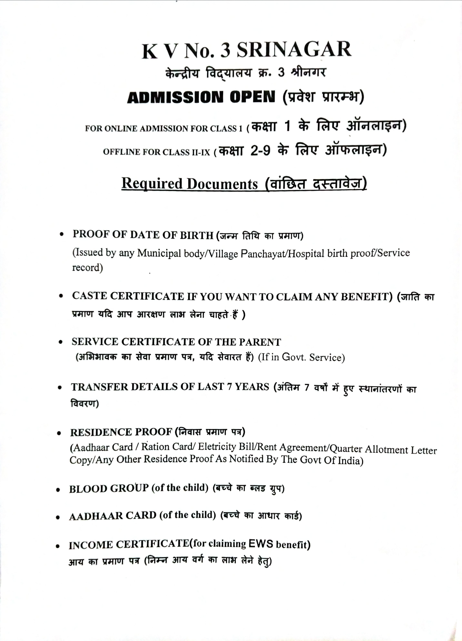

**KENDRIYA VIDYALAYA PAHALGAM**